A000-AM,C-Taino-Mask-Anthropomorphic-Ear Spools-Andesite-1000 CE



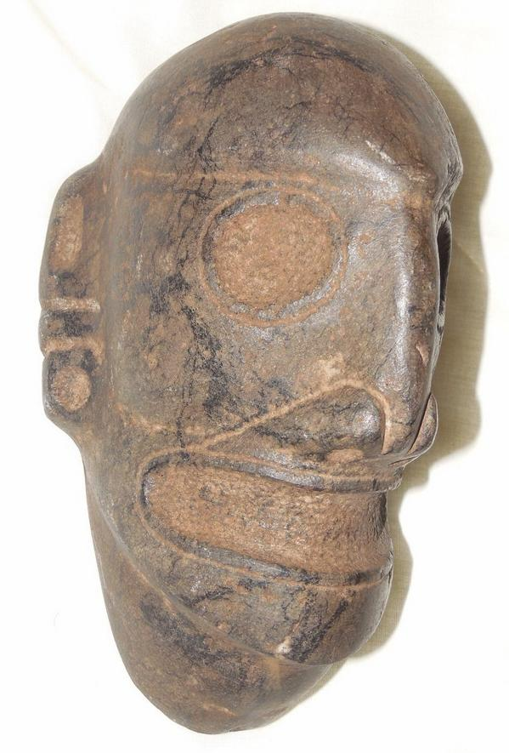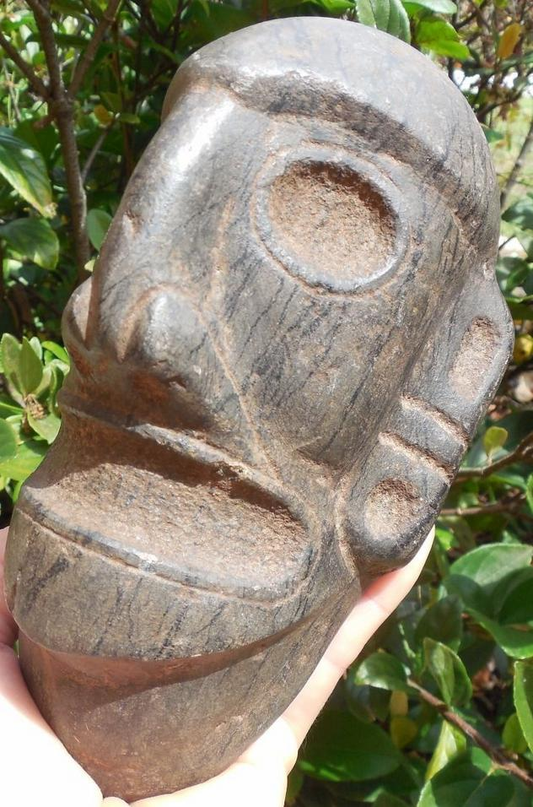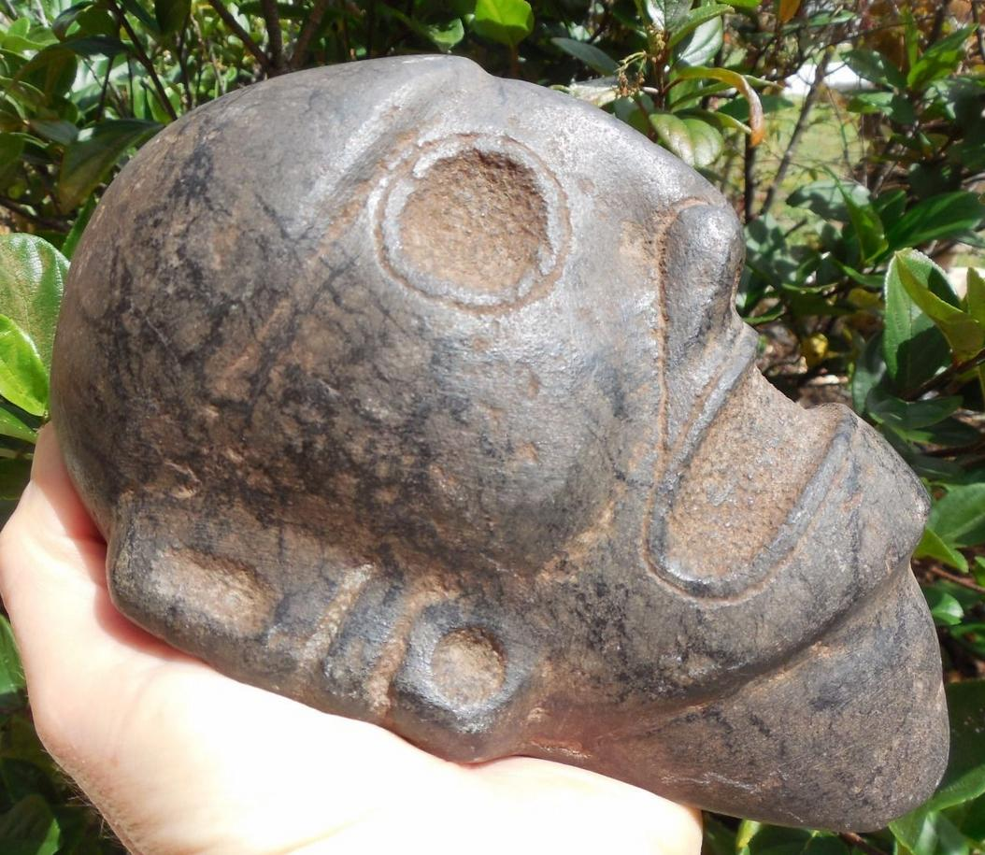

AM,C-Taino-Mask-Anthropomorphic-Ear Spools-Andesite-1000 CE

**Case No.: 17**

**Accession No.**

**Formal Label:** AM,C-Taino-Mask-Anthropomorphic-Ear Spools-Andesite-1000 CE

**Display Description:**

This large anthropomorphic mask of a cemi was shaped so that it could be placed in sandy soil with its pointed throat in the soil. It may have been used as in the rituals where masks were often used as intermediaries between the Great Spirit and the people.

**LC Classification: F 1909**

**Date or Time Horizon: 1000 CE**

**Geographical Area: Caribbean**

**Map:**

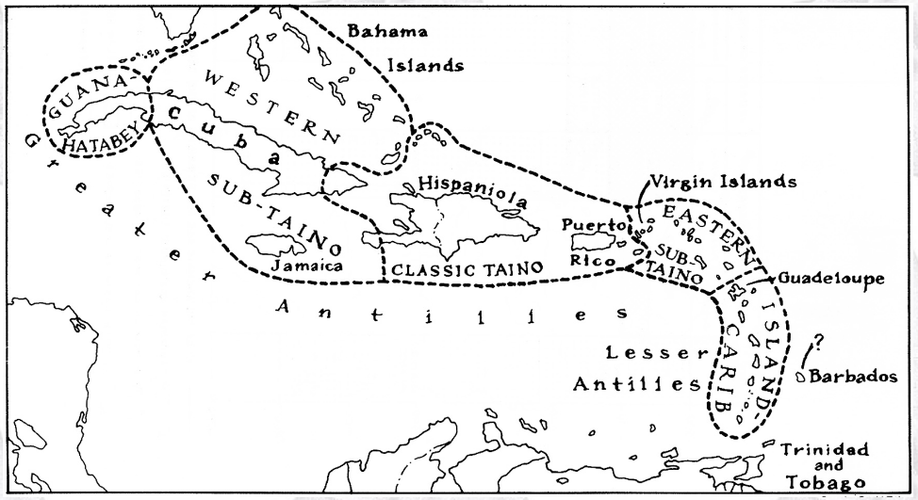

**Caribbean c 1500 after http://www.latinamericanstudies.org/maps/Ciboney-Taino-Carib-map.jpg**

**GPS coordinates:**

**Cultural Affiliation: Tainos**

**Medium: andesite with zeolite crystal inclusions**

**Dimensions:**

**Weight:**

**Condition: original**

**Provenance:**

**Discussion:**

**References:**